For editing
Food Diary (MyFitnessPal) Instructions
You will use MyFitnessPal to record your daily intake.
Register for a free account at https://www.myfitnesspal.com/
  - You may use your personal or school email address.
  - The tools you will use for this assignment are free.
  - You do not need to use any of the tools with the lock symbol .

When you register, you will be prompted to enter your personal information.
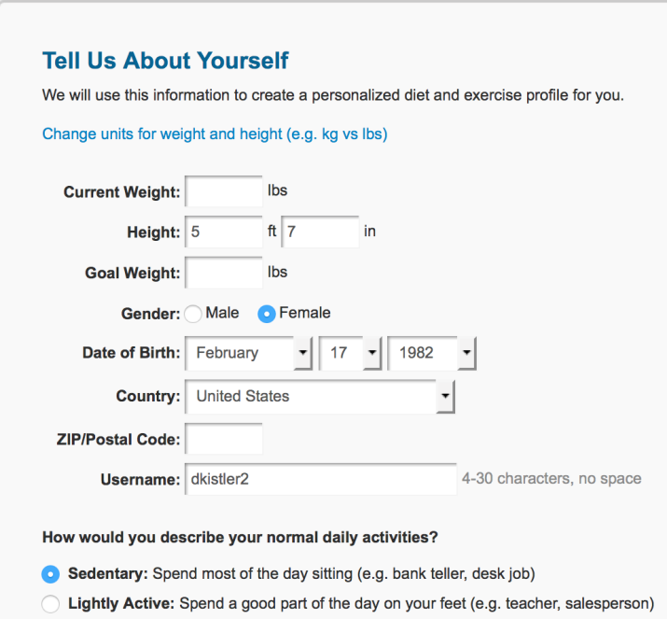
Click Food or Add Food to begin tracking your intake. Track your intake for three days. It is preferable to record at least one day that is a non-school day or a non-weekday. This way, you can see how your eating habits change with your schedule.
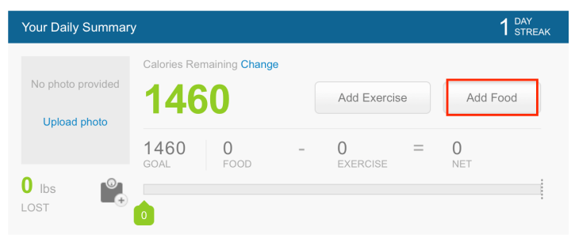

Record everything that goes into your digestive system over the course of three days. Record everything you eat and drink, and record the name and dosage of any medications that you take including vitamins, minerals, and herbal supplements.
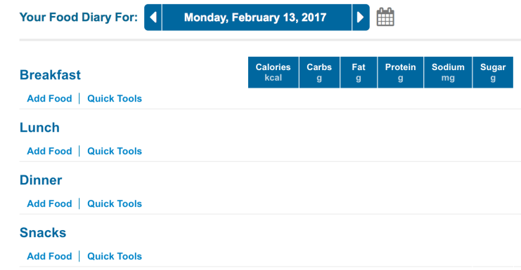
Record your activity and moods in the Notes section for each day. Remember to SAVE every time you edit; otherwise, your notes will be lost.
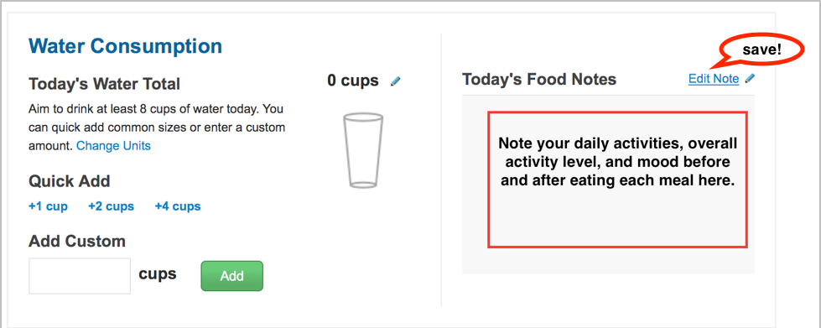
Daily Reports
You will need to access MyFitnessPal reports for your written paper. Use this spreadsheet to track your daily nutrient intake.
Go to Reports.
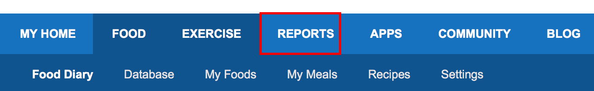

Choose a Report: Use the drop-down menu to select a report for each of the nutrients listed.
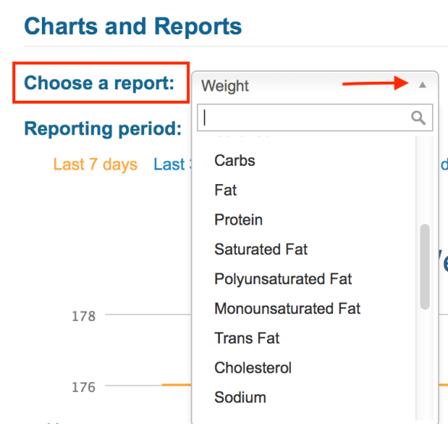
Record the recommended intake and your actual intake of each nutrient for each day.
  - Hover your mouse over the red line to get the recommended daily goal percentage.
  - The blue bar indicates your actual intake percentage.
  - Put these numbers on the spreadsheet.
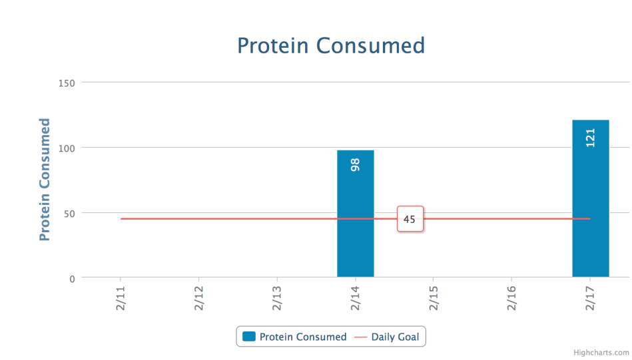
Complete the spreadsheet for each day and each nutrient.
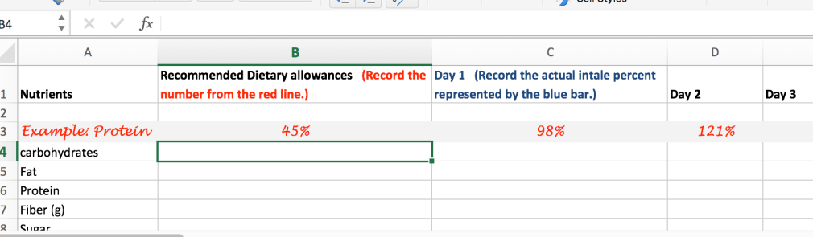

- Save and upload your completed spreadsheet with your written anlaysis paper.
- Take screenshots of your food diary to include in your analysis paper.
- At the end of the three days, print the final report in MyFitnessPal to include with your written assignment.

